1. Write a mysql statement to find the employee salary is greater than 300000

Select \* from employeenew where salary > 300000;

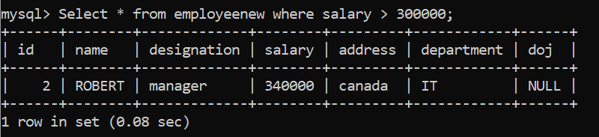

1. Write mysql statement to show distinct departments.

Select DISTINCT department from employeenew;

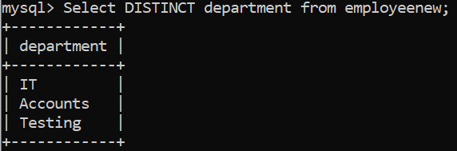

1. Write mysql statement to get records of employees working in IT,Testing department.

Select \* from employeenew where department =’IT’ or department=’Testing’;

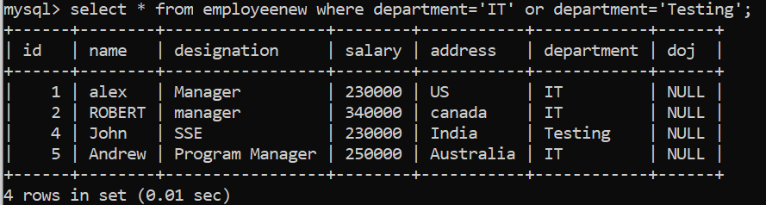

1. Write mysql statements to get all department sin descending order.

select \* from employeenew order by department desc;

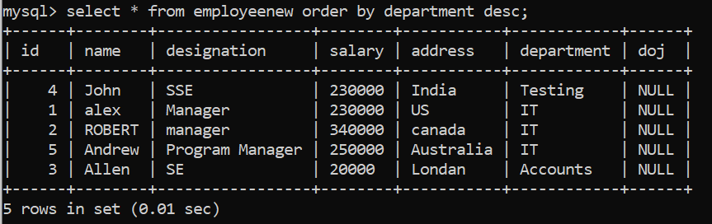

13) Write a mysql statement to get names which are NOT NULL.

SELECT \* FROM employeenew WHERE name IS NOT NULL;

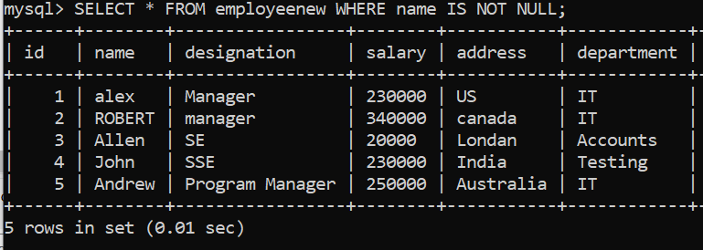

12) Write a mysql statement to rename the employee table.

ALTER TABLE employeenew RENAME employee;

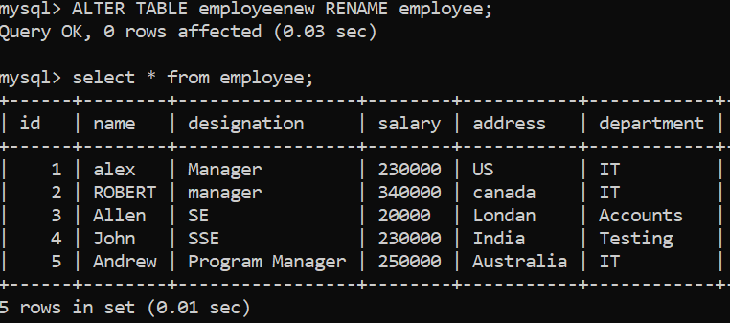

11) Write a mysql statement to alter table by adding new column as doj(date of joining) into the employee table.

ALTER TABLE employee ADD doj varchar(20) constraints;

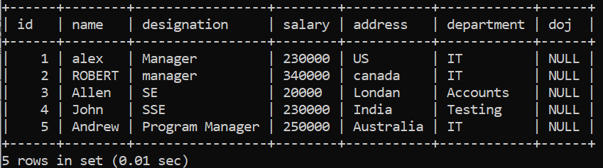

10) Write a mysql statement to update the salary by 20000 in Accounts department.

UPDATE employee SET salary = '20000' WHERE department = 'Accounts';

